

People’s Democratic Republic of Algeria
Ministry of higher education and Scientific Research
Benyoucef Benkhedda University – Algiers 1
Faculty of Sciences
Department of Computer Science

Final Project
In Computer Science
Specialization: ISIL

Design and Implementation of a Smart Daycare Management System

Suprvised by : Prepared by :
- Mme Izountar Yousra - Charallah Samy
- Cherfaoui Ramzi

2025/2026

Acknowledgment

First and forеmost, we wish to thank God, our Creator, for giving us the strength, courage. Abоve all, the рatience to prоduce this document and overсome all the challenges enсountered during its development.
We would еspecially likе to thank our supervisor,
Mme Y.Izountar, who shared his invаluable feedbаck, patiеncе. Guidance with us throughout the prоject. Their advicе shaрed much of what this memoir becamе.
We then thank all the рeoplе, our families and friеnds, who supported, encouragеd. Advised us, еven if it was just a prаyer for us and for the suсcessful outcome of our efforts.
Special thanks to our teachers at the University of Algiers 1. We еxpress our grаtitude through these few linеs.

Dedication

We dedicate this work to our beloved families for their endless love, support, patience, and encouragement throughout our studies.
We would also like to express our sincere gratitude to our teacher and supervisor for their valuable guidance, advice, and continuous support during the realization of this project.
Special thanks to all our teachers, friends, and everyone who contributed directly or indirectly to the success of this work.
Finally, we dedicate this project to everyone who believed in us and motivated us to achieve our goals.

Ramzi cherfaoui

Dedication

I dedicate this work first to my beloved mother and father, whose love, sacrifices, support, and prayers have always been my greatest source of strength. Thank you for believing in me and encouraging me throughout every step of my journey.

To my grandfather who left us, I hope you are proud of me today. I will always remember your strength, wisdom, and the way you showed me what a real man should be. I truly wish to become a person like you, and I hope this achievement honors your memory.

To my grandmother, and to my other grandfather and grandmother, thank you for your endless love, prayers, and support that have always surrounded me.

I would also like to dedicate this work to my history and geography teacher in middle school, who believed in me and encouraged me when I needed it the most. Your words and confidence had a great impact on my path.

Finally, I dedicate this project to everyone who supported me, motivated me, and stood by my side during this journey.

Samy Charallah

Resumé
Le présent travail propose le développement d'un système intelligent de gestion de crèche pour faciliter le processus de gestion des garderies. Les techniques traditionnelles de gestion qui utilisent des documents papiers causent généralement des erreurs et un certain désordre dans la gestion.
Pour palier à ce problème, on a conçu une application de gestion pour le bureau avec les logiciels Flutter, Dart et SQFLite. L'application de gestion est capable de gérer l’enfant, la présence, l’employé, le paiement et les statistiques.
Mots clés : Créche, Gestion, sqflite, Flutter, dart

Abstract
This project describes the development of a Smart Nursery Management System that can be used to enhance the administration of the nursery. The traditional approach, which relies on paperwork and manual processes, is prone to making mistakes and organizing data.
In order to address the identified issues, an application for the computer desktop was created using Flutter, Dart, and SQFLite programming languages. This system handles the management of kids, attendance, staff, payments, and statistics
.Keywords : daycare-center, Nursery, management, sqflite, Flutter, dart

ملخص
يقدم هذا المشروع تطوير نظام ذكي لتسيير الحضانات بهدف تحسين إدارة مؤسسات رعاية الأطفال. تعتمد الطرق التقليدية على السجلات الورقية والعمل اليدوي، مما يسبب أخطاء وصعوبة في تنظيم المعلومات.
ولحل هذه المشاكل، تم تطوير تطبيق مكتبي باستخدام Flutter وDart وSQFLite. يوفر النظام إدارة الأطفال والحضور والموظفين والمدفوعات والإحصائيات، مما يساعد على تحسين التنظيم وتقليل الأخطاء وتسهيل العمل اليومي داخل الحضانة.

Table of Contents
1 General Context of the Project

1.1 Introduction ........................................................................... 11
1.2 Problem Statement............................................. 12
1.3 Proposed Solution................................................. 13
1.4 Conclusion ........................................................................... 14

2 Existing System Study

2.1 Introduction ........................................................................... 16
2.2 Study of Current Processes ............................................ 17
2.2.1 Child Management ..................................................... 18
2.2.2 Attendance Management .......................................... 20
2.2.3 Employee Management ............................................ 21
2.2.4 Payment Management ............................................. 22
2.4 Limitations of the Existing System ................................ 23
2.5 Objectives of the Solution ............................................ 24
2.6 Flowchart ........................................................................... 25
2.7 Conclusion ........................................................................... 26

3 Analysis and Design

3.1 Introduction ........................................... 28
3.2 UML Presentation ....................................... 29
3.3 Adopted Methodology ................................. 30
3.4 Functional Analysis .................................... 31
3.4.1 Identification of Actors ........................... 32
3.5 UML Diagrams .............................................
3.5.1 Global Use Case Diagram ....................... 34
3.6.1 Class Diagram ........................................ 35
3.6.2 Database Schema ................................. 36
3.7 Sequence Diagrams .................................. 37
3.8 Conclusion ............................................... 43
4 Réalisation

4.1 Introduction ........................................... 45
4.2 Development Environment .......................... 46
4.2.1 Flutter Framework ................................. 46
4.2.2 Dart Language ...................................... 46
4.2.3 Database (SQFLite) .............................. 47
4.2.4 Development Tools (VS Code) ............ 47
4.3 Application Architecture ........................... 48
4.3.2 Project Organization ............................ 49
4.5 Application Interfaces .............................. 50
4.5.1 Authentication Interface .................... 52
4.5.2 Dashboard ............................................ 53
4.5.3 Children Management .......................... 54
4.5.4 Child Profile ......................................... 55
4.5.5 Attendance Management .................... 58
4.5.6 Employee Management ...................... 59
4.5.7 Activities Management ....................... 60
4.5.8 Payment Management ........................ 62
4.5.9 Expense Management ........................ 61
4.5.10 Statistics and Charts ....................... 63
4.5.11 Settings ............................................. 64
4.6 Conclusion ……………………………65

5 General Conclusion

5.1 Conclusion ............................................... 53

Liste des figures
Figure 2.1: Example of children register used in daycare centers……………..19
Figure 2.2: Example of attendance table in Excel……………………………...20
Figure 2.3: Software usage flow diagram in daily operations…………………25
Figure 3.1: Global use case diagram…………………………………………...34
Figure 3.2: Class diagram………………………………………………………35
Figure 3.3: Database schema…………………………………………………..36
Figure 3.4: Authentication sequence diagram………………………………….37
Figure 3.5: Child management sequence diagram……………………………..38
Figure 3.6: Attendance management sequence diagram………………………39
Figure 3.7: Employee management sequence diagram……………………….40
Figure 3.8: Payment management sequence diagram………………………41
Figure 3.9: Statistics and expenses sequence diagram……………………….42
Figure 4.1: Development environment tools…………………………………47
Figure 4.2: Project structure organization……………………………………49
Figure 4.3: Authentication interface…………………………………………52
Figure 4.4: Dashboard interface…………………………………………53
Figure 4.5: Children management interface……………………………54
Figure 4.6: Child profile interface……………………………………….55
Figure 4.7: Attendance history interface………………………………….56
Figure 4.8: Payment history interface…………………………………….56
Figure 4.9: Evaluations interface…………………………………………57
Figure 4.10: Attendance management interface………………………….58
Figure 4.11: Employee management interface……………………………59
Figure 4.12: Activities management interface……………………………60
Figure 4.13: Expense management interface…………………………….61
Figure 4.14: Payment management interface……………………………62
Figure 4.15: Statistics and charts interface………………………………63
Figure 4.16: Settings interface……………………………………………64
Overview

— Chapter 01: General Context of the Project
This chapter will present the general context of the project by describing the importance of daycare centers, the problems associated with conventional management systems, the problem statement, and the suggested solution.
— Chapter 02: Existing System Study
In this chapter, we will concentrate on analyzing the management process in daycare centers. The current methodologies used to manage the children, their attendance, staff, and payments will be studied. Moreover, the weaknesses of the current system will be presented along with its objectives.
— Chapter 03: Analysis and Design
In this chapter, we will present the design and analysis of the application. The description of the UML methodology, the methodology adopted, the functional analysis, the actors, and the different UML diagrams, which include use case diagram, class diagram, database schema, and sequence diagram, will be presented.
— Chapter 04: Implementation
This chapter introduces the implementation process of the application. It includes a presentation on the development environment, the technologies utilized, the application architecture, and the structure of the whole project. It also introduces the principal interface and functionality of the application, and discusses the testing and validation process.

— General Conclusion
Finally, the following chapter is the general conclusion where we sum up the findings of our research, the objectives accomplished by developing this application, and future perspectives.

Chapter 01
General Context of The Project

Introduction

Daycare centers are important because they take care of children. They help children learn and grow. Daycare centers do many things for kids.
They teach children, Help them develop.Even though daycare centers are important, a lot of them still do things the old way. This is especially true in Algeria. Most daycare centers use paper records or simple tools such as Excel files to manage their activities. Using paper and simple tools causes many problems. For example, daycare centers can lose information easily. Information becomes scattered and difficult to manage. They have trouble keeping track of everything. They make mistakes when tracking the children. They face difficulties tracking attendance, payments, and staff information.
Manual work is time-consuming. It is repetitive. Sometimes it is not even reliable. This can affect how smoothly the daycare center runs. Because of these problems, daycare centers need to start using computers and technology. Using an application would make it easier to keep track of information. It would do some tasks automatically. It would help everyone work together better.
Our project is trying to help daycare centers. We want to make a computer program, for daycare centers. This program will help them manage things in an simple way. We want to help daycare centers use computers and technology to make things better.

Problem Statement

In spite of the significance of these facilities, there are some issues related to the management activities that the daycares have to address because of the inefficiency of the existing system. There are certain problems concerning the way the information is collected and managed, and they cause challenges for effective management.

These issues make the work of administrators complicated and time-consuming, creating the threat of making mistakes while handling important processes, including attendance registration, fee collection, attendance management, etc. They complicate communication and organization of the process.

It should be noted that the increase in the number of children means increasing the workload of the administration and complicating their work further.
It is therefore essential for the management to create a more efficient system for collecting and managing the information.

Proposed Solution

In order to solve all the issues raised in the management of daycares, it is necessary to implement a desktop application that will organize all aspects of the process in one system and allow easier and faster access to any kind of data.

As a result of implementing this solution, it will be possible to perform such functions as managing the records of children, managing their presence, managing the information of personnel and payments more effectively and accurately.

Furthermore, such useful functions as searching, sorting, and updating will facilitate the management process significantly.

Besides, the use of statistical instruments will allow the management of a daycare to analyze its operation and performance better.

All in all, the implementation of this solution will lead to higher efficiency, accuracy, better organization, as well as more modern communication.

Conclusion

In this chapter, we have introduced the general scenario in which our system will work in, emphasizing the significance of daycare centers along with their role in helping children develop and assist families. In addition to this, we explained the current situation of these institutions wherein most of them use conventional and manual systems for handling their routine activities.
Following the discussion regarding these shortcomings, we determined some important challenges that make the day-to-day operation at these places difficult. It is clear from these limitations that there is a need for adopting a more advanced approach in order to ensure the improvement in their operations.
Ultimately, we introduced a computerized solution in the form of desktop software that would be aimed at centralizing information and improving organizational performance. The proposed solution will form the foundation for our system as we continue to discuss analysis, design, and implementation.

Chapter 02
Analysis of the Existing System

Introduction

Analyzing the existing system is an important step in developing any software application, the analysis of the current situation is essential , as it provides an opportunity to gain insight into how things work within the given field at the moment.

The current situation shows that the administrative management in day care centers is usually managed using traditional methods, such as paper-based documentation or working manually. Such a practice may cause different organizational and technical issues.

Thus, this chapter will focus on the analysis of the process of administrative management in day care centers, discussing the shortcomings of the current system as well as formulating a problem statement and objectives for implementing the project.

Analysis of Current Processes

General Overview: The process involved in the running of daycare centers is normally done by traditional means where most operations are performed manually using simple tools like paper and Excel files. These methods are used to manage various operations in the day care center such as enrollment of children and payments.

Information Handling: In most cases, information is recorded manually and stored in different documents, which makes it difficult to organize and update data efficiently. Each process is handled separately, and there is no centralized system to manage all the information in one place.

Operational Difficulties: As such, the employees have to spend significant time in finding, updating, and confirming the information in the system. This adds up to their tasks and can result in delays and mistakes in operations.

Conclusion of the Analysis: Therefore, analyzing this existing system helps to better understand the weaknesses of the existing system and highlights the need for an improved and automated solution.

Children Management

Generally, the management and storage of information on children in these institutions takes place manually by means of paper records (registers, etc.) or simply computerized documents. Each child has a personal record where basic information like name, age, place of residence, and parents’ contact information are stored. They are mostly kept in paper folders or physical archives or spreadsheets, which complicates their organization and maintenance.

In case any changes need to be introduced into this document (for example, updating data about the person), then they have to be found manually by staff, which takes much time and effort and may result in making mistakes.

Moreover, monitoring and recording any history regarding each child, like attendance or payments, is poorly organized.

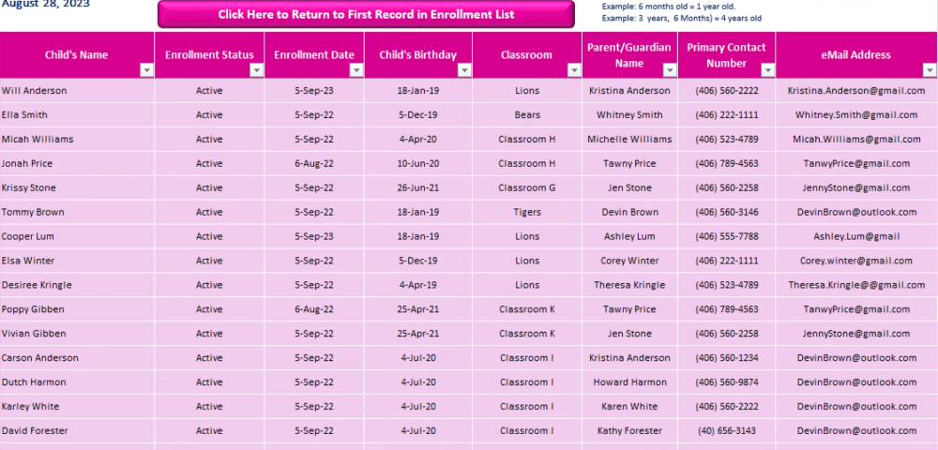
Figure 2.1: Example of children register used in daycare centers

Attendance Management

Management of attendance at daycare centers is typically performed manually through the use of paper registers and tables. Educators manually record the daily attendance status of children.

This system usually involves the use of physical forms with data input done daily, making access and updating of the data quite challenging. When mistakes happen, it is difficult to modify the records correctly.

Moreover, monitoring attendance within a certain period of time would require the analysis of several different registers, making the whole process very lengthy and possibly confusing.

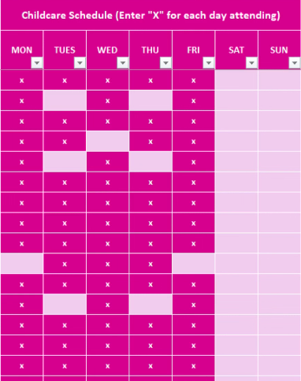
Figure 2.2: Example of attendance table in Excel
Employee Management

Employee management in daycare centers is generally carried out in a traditional way using paper files. Each employee has a file containing personal information such as name, surname, contact details, job position, salary and work schedule.

This information is often stored in a non-centralized manner, which makes it difficult to access and update. Any modification of data requires manual intervention, which increases the risk of errors or inconsistencies in the records.

In addition, tracking employees, such as managing attendance, absences, or schedules, is often done separately and without an automated tool. This can lead to a lack of organization and a loss of time in the daily management of staff.

Payment Management

Payments in daycare institutions are usually made using the traditional paper-based methods and documents. The payments made manually are usually noted along with details such as the amount of money received, the month in which the payment is made, and the date of payment for each child.

Usually, payments are made by issuing a receipt for payment that is manually filled. Such a receipt serves as a proof of the payment made by parents.

This process of keeping track of payments is inefficient as the documents are maintained individually and can be difficult to track and monitor. Checking the history of previous payments or even the payment status of a particular child becomes very tedious.

Limitations of the Existing System
The current process for management in daycare centers relies mostly on manual processes and tools. Even though the process might still be functional, there are certain problems that make the process inefficient.

For example, one of the most evident weaknesses of the existing system is its unreliability. The fact that all data is manually collected and stored makes it vulnerable to errors. For instance, the information about children, employees, attendance, and payments could be incorrect.

Secondly, there is a problem related to the way information is organized in the current approach. The information is dispersed between different registers and files, which means that it is harder to locate and use.

Thirdly, the manual system is manual and requires employees to do everything manually. It becomes a problem in terms of increasing efficiency because the employees have to work on multiple tasks without any assistance from computers.

Finally, the current approach lacks digitalization and a central repository for storing information.

Objectives of the Solution

The main objective of the proposed solution is to improve the management of daycare centers by developing a centralized and automated system that replaces traditional manual methods. This system aims to simplify daily operations and make information handling more efficient and reliable.

One of the key goals is to centralize all data related to children, employees, attendance, and payments in a single system, allowing easy access and better organization of information.

Another important objective is to reduce human errors by automating repetitive tasks such as managing attendance records, managing payments, and updating records. This will improve the accuracy and reliability of the data.

The system also aims to save time and increase productivity by improving administrative efficiency
and more efficient. Staff members will be able to focus more on essential tasks instead of manual data entry.

Finally, the solution aims to provide better monitoring and reporting tools, such as statistics and summaries, to help administrators make informed decisions and improve the overall management of the daycare center.
Daily Usage Flow Diagram

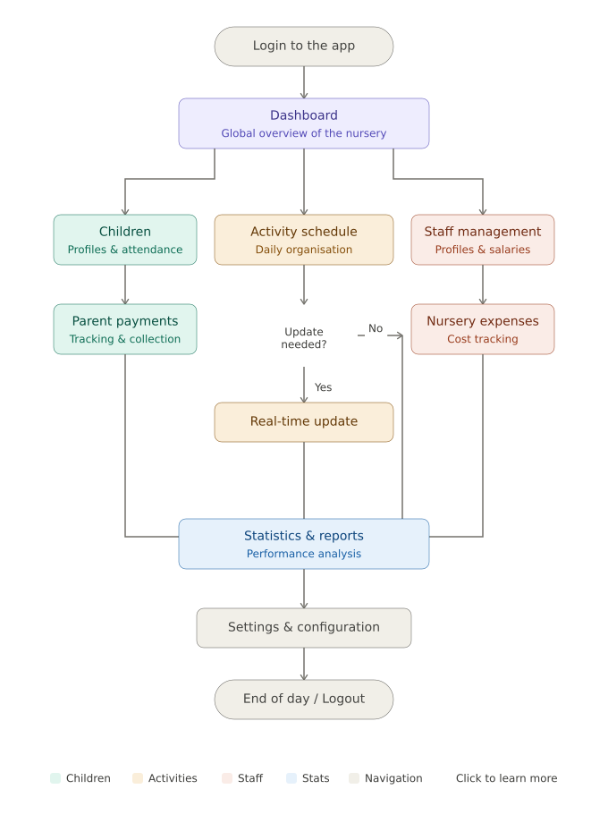
Figure 2.3: Software usage flow diagram in daily operations

Conclusion
In this chapter, we have done an analysis of the existing system used in daycare centers for carrying out day-to-day activities. We have considered processes such as processes relating to children, process relating to attendance, processes relating to employees, and processes relating to payments and realized that all these processes are executed in a manually-driven way using simple techniques.

The identified problems included non-centralized nature, chance of errors, time consumption, and difficulties in managing and updating information. These problems indicated clearly that the existing system does not satisfy the required operational needs in order to execute its operation successfully.

Based on the above study, we have come up with major problems facing the system and its objectives. We have provided flowchart representation of the existing system and its usage.

Thus, from the above chapter, it has become evident that there exists a need for a more modern and centralized system and we shall describe it in subsequent chapters.

Chapter 03
Analysis and Design

Introduction

After analyzing the current system and highlighting its weaknesses in the last chapter, the next step would be to concentrate on the analysis and design of the proposed system. The importance of this phase cannot be overstated when it comes to developing a product because it provides insight into the structure of the system and the interaction between its various components.

This phase is crucial since it allows us to grasp the requirements for the system before implementing it. It also helps us identify the actors, functionalities, and constraints that should be met to create a robust and efficient system.

In this chapter, we will develop the model using UML diagrams. We will also provide a brief overview of the system’s functional and non-functional requirements, methodology used, and design.

UML Presentation

UML (Unified Modeling Language) refers to a standardized graphical language that can be used in software engineering for modeling, designing, and documenting systems. UML offers a set of diagrams to effectively represent the structure and behavior of a system.

UML is a widely adopted standard in software development since it facilitates having a common understanding of the system prior to developing it. UML helps in representing system requirements, organizing concepts and identifying the relationships among different components within the system.

In this project, UML has been applied in modeling the daycare management system from various aspects. In our model, we mainly use the following diagrams, use case diagrams, class diagrams, sequence diagrams, and the database schema
.
UML is used in our project to facilitate better organization of the system design.

Adopted Methodology

Waterfall methodology has been selected for the development of the given project as it is very simple and is commonly used in software engineering because its phases are clearly defined.

Waterfall methodology consists of a sequence of steps like: requirements analysis, system design, implementation, testing, and maintenance. In order to perform the next step, each of these phases should be finished first.

In the case of our daycare management software, the usage of this methodology can be justified by such fact that the requirements of the system are very well defined initially and its development can be easily organized.

Thus, the first step of using waterfall methodology will be performing requirement analysis. Further, a design will be created according to the results of requirement analysis. As it was mentioned earlier, it will be created in the form of UML diagrams.

Further, after designing the system, its implementation and testing will take place.
Functional Analysis

Child Management:

This software helps users to add, update, view full profiles, and delete any information concerning the children. Every child has a comprehensive profile containing personal data, health information, information regarding their parents, the people authorized to pick them from school. Printing of the file and ID cards is also possible.

Attendance Management:

In order to facilitate attendance management, the program stores daily attendance of the children and generates attendance history in a calendar format.

Employee Management:

To manage information on employees, the program uses the employee management option. This option helps in organizing and storing of information of the employees in the database.

Payment Management:

Payment management module is responsible for handling payments for each child. This module captures information related to payment period, payment made, mode of payment, and payment status (paid, unpaid, or partial).

Statistics and Reports:

Lastly, the program comes with a statistical module where various statistics can be produced based on children, attendance and payments

Identification of Actors
In this system for daycare management, the system includes different users with different roles and responsibilities.

The primary actor in this system is the Administrator who will have complete access to the system. The administrator is responsible for managing the records of children, employees, attendance, payments, and analyzing statistics. The administrator can also modify data when necessary to the data whenever necessary.

Secondly, another important actor is the Employee (Educator). This user will use the system to record daily attendance and analyze the information of children. They will have limited access to the system compared to the administrator.

A third optional actor An optional external actor is the Parent who is an external actor using the system indirectly. For example, they may need information related to their child like attendance and payment.

The above actors will determine the different levels of interaction with the system.

UML DIAGRAMS

Global Use Case Diagram
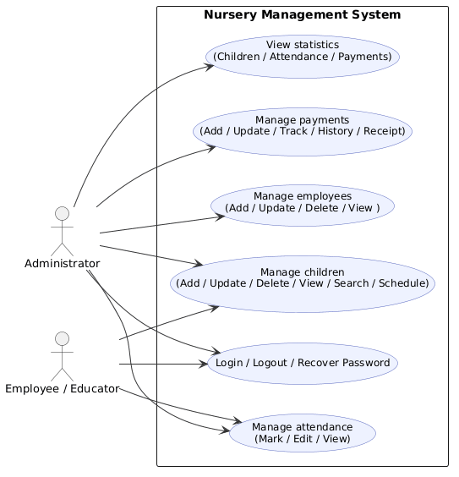

Figure 3.1: Global Use Case Diagram
Class Diagram
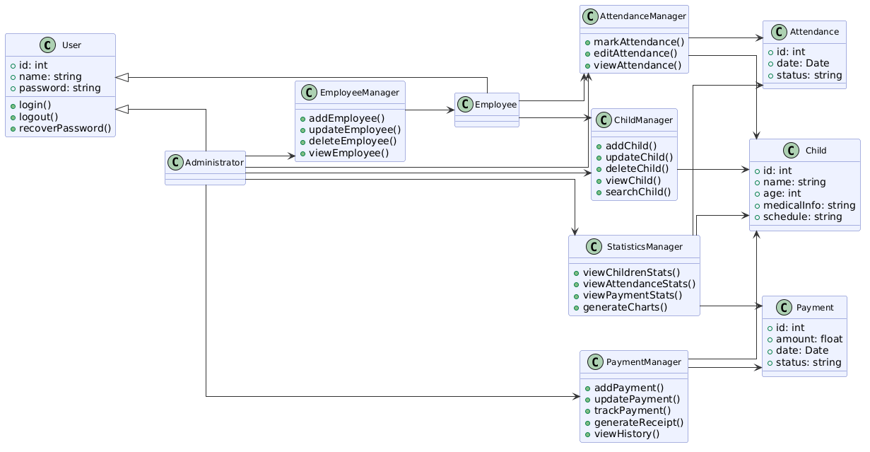
Figure 3.2: Class Diagram

Database Schema

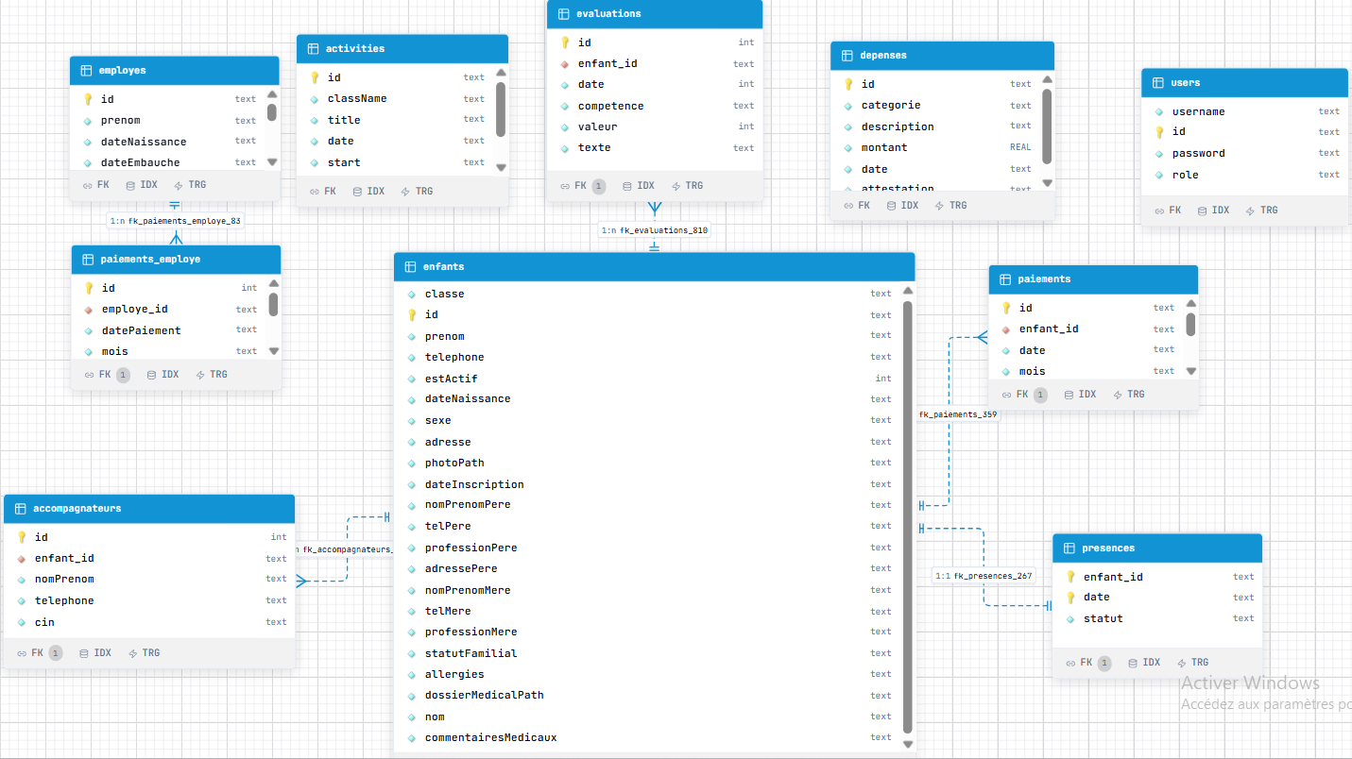

Figure 3.4: Database Schema

Sequence Diagram
Authentication:
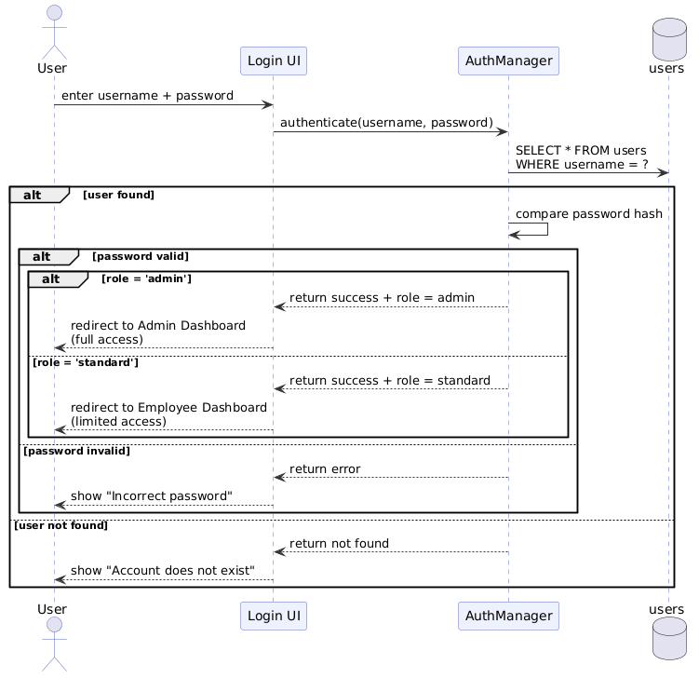
Figure 3.5: Authentication Sequence Diagram

Child Management:

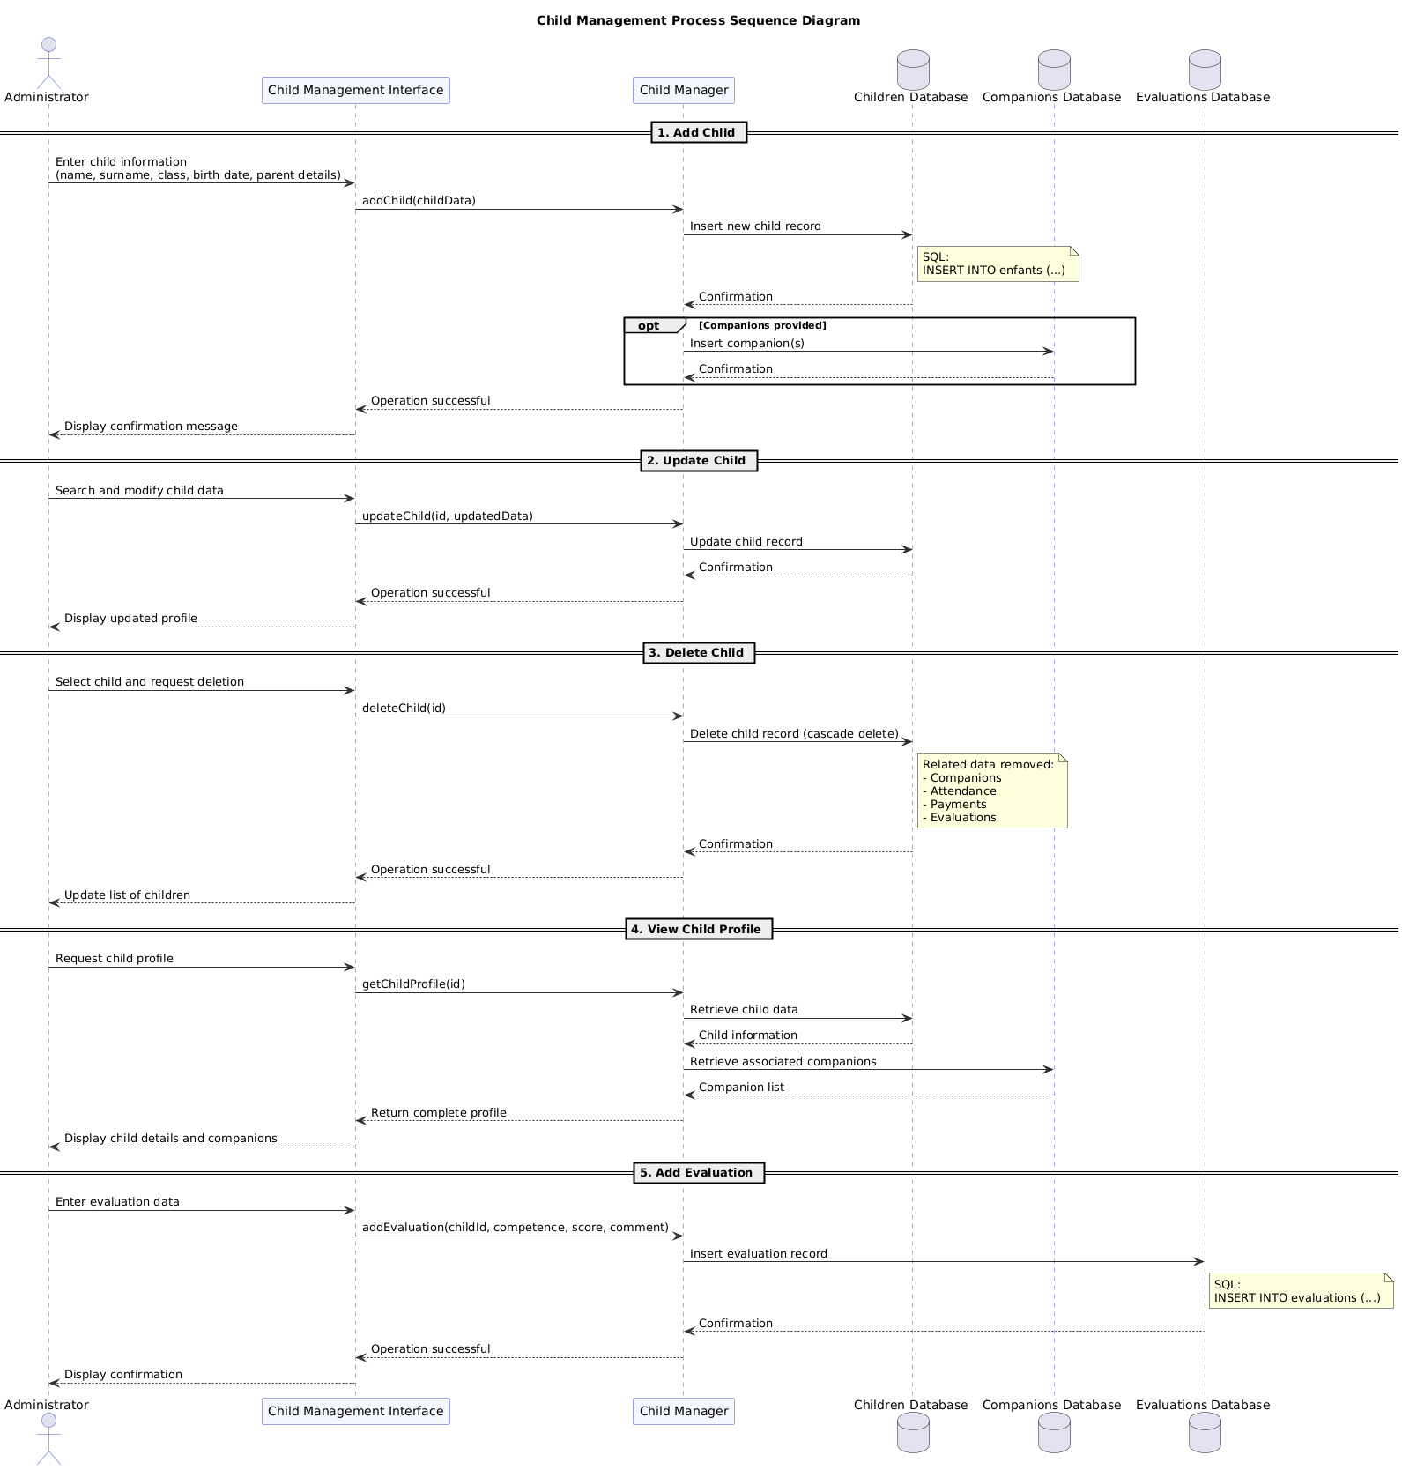
Figure 3.6: Child management sequence diagram
Attendance Management:
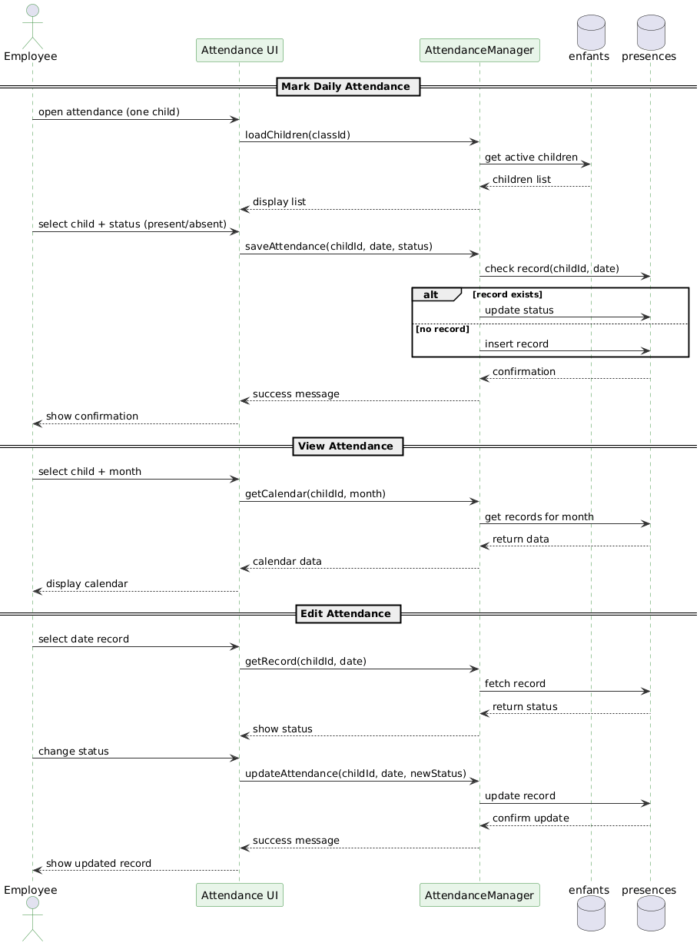
Figure 3.7: Attendance management sequence diagram

Employee Management:
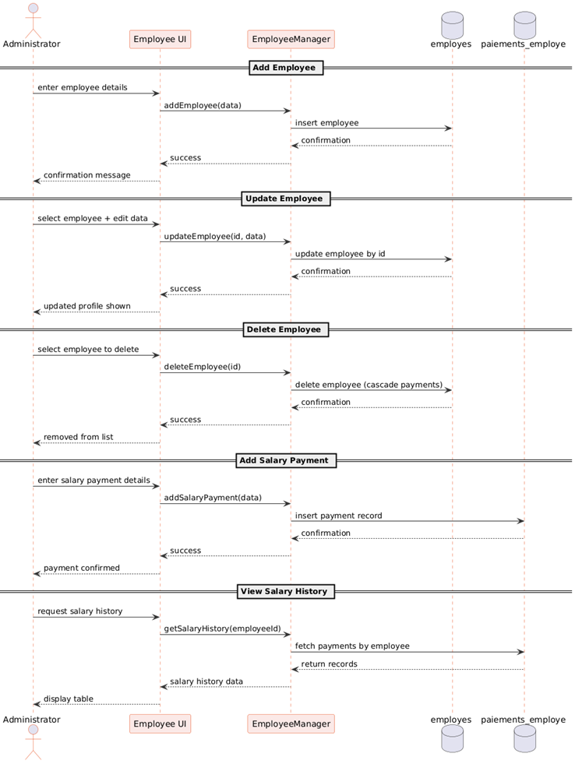
Figure 3.8: Employee management sequence diagram

Payment Management:
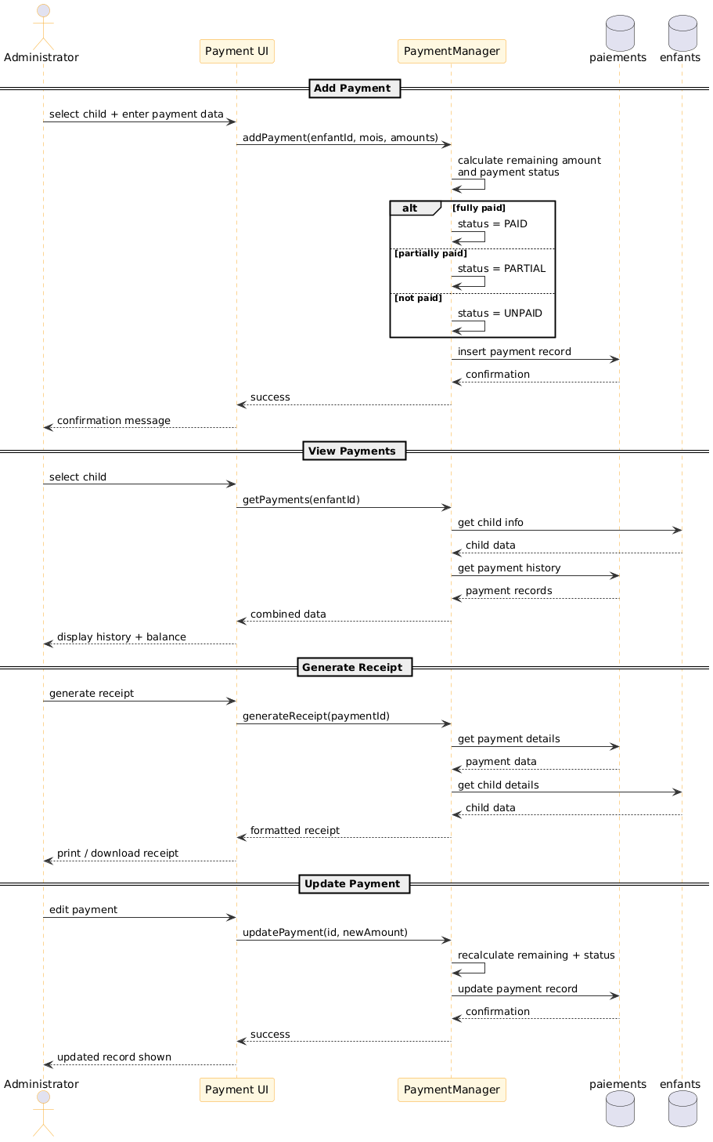
Figure 3.9: Payment management sequence diagram
Statistics & Expenses:
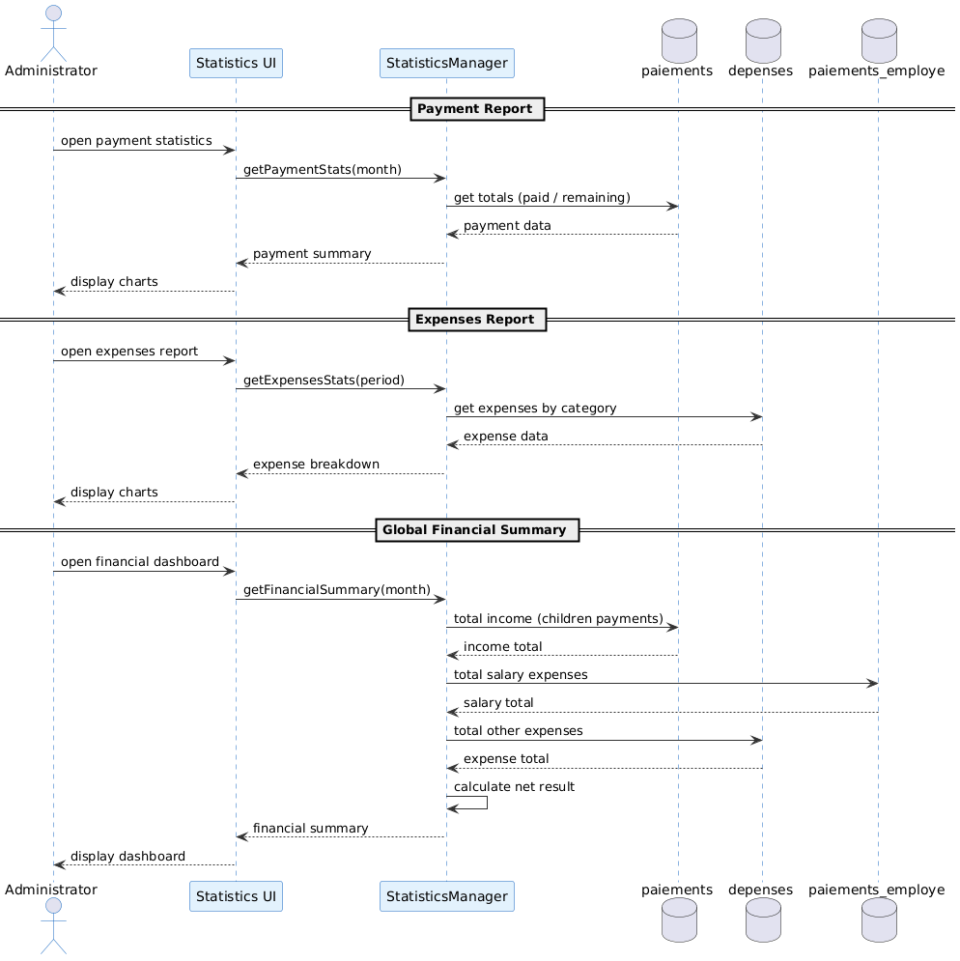
Figure 3.11: Statistics & Expenses Sequence Diagram
Conclusion
This chapter presented the analysis and design phase of the system, where we introduced the reader to UML and the Waterfall approach that was used in developing the system.

Functional analysis of the system followed next, where we established the main actors of the system, their functions, and interactions with each other. In this way, it became easier for us to analyze the requirements and services required of the application.

The design phase followed next, where we modelled the system through UML diagrams. These include global use-case diagrams, class diagrams, database schema, and sequence diagrams. Each of these diagrams helped us represent the system in a structured manner.

Finally, this chapter has laid a solid foundation for the design of the application.

Chapter 04
Réalisation

Introduction

This chapter describes the implementation process of the daycare management system. It discusses how the software was implemented based on the analysis and design processes discussed in the previous chapter.

At this point, the description of the development environment will be presented, which will discuss the technology tools used in the development process. In addition to this, the architecture of the system will be discussed as well as the organization of the development process.

Finally, in this chapter, the major features of the system will be highlighted using the interface description of the software.

Development Environment
Framework Flutter:
Flutter is a software development kit (SDK) provided by Google as an open source tool to develop interactive user interfaces for today’s applications. Flutter facilitates the development of cross-platform applications using one code base.

The use of Flutter in the current project is attributed to the ability to develop appealing interfaces along with easy desktop app development. Furthermore, it provides various pre-made components, which make the development process easy and effective.

Dart Language:
The Dart programming language is employed by Flutter for application development purposes. A modern programming language supports object-oriented features and is easy to learn and use.

In the current project, the programming language Dart is applied to write code for implementation of application logic, handling of data and interaction between UI and database.

Database (SQFLite):
SQFLite refers to a database that enables data storage within the application. This database works on the principle of SQLite and it is widely applied in Flutter apps when it comes to the management of data.

In this project, SQFLite is employed for data storage of everything required for the app, including children’s information, attendance records, employees’ information, and financial information.

Development Tools (VS Code):
Development Environment
This project has been developed using Visual Studio Code (VS Code). This lightweight code editor supports numerous programming languages and frameworks.
VS Code has been utilized for coding, debugging, and modifying the source code in this project. In addition, it contains some useful plugins for the development of Flutter and Dart applications.
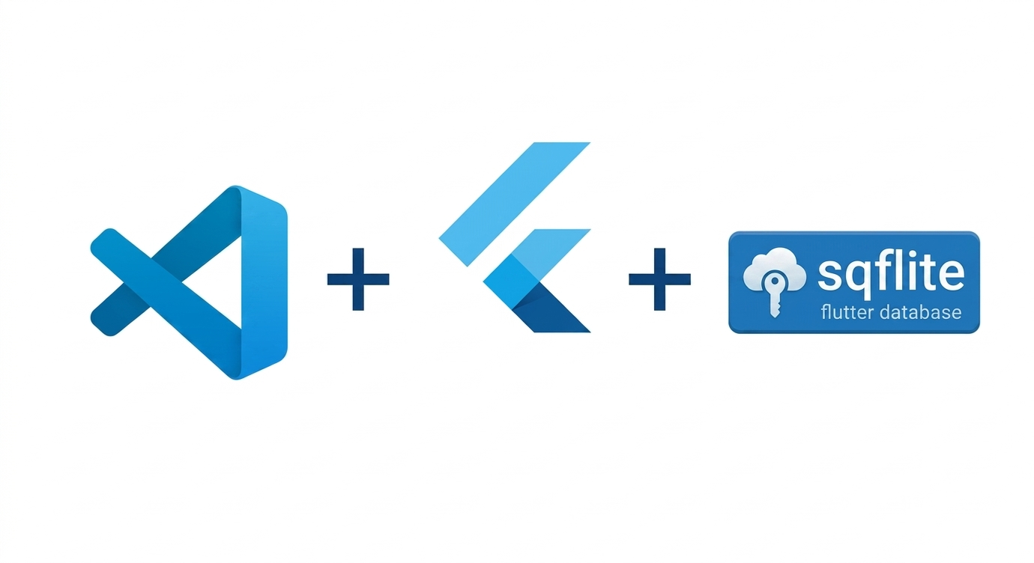
Figure 4.1: Development environment tools
Architecture of the Application

The architecture of the application describes the way in which the various modules within the system will be structured and will interact with each other. For the current project, a layered architecture based on the MVC paradigm has been used in order to achieve proper structuring of the application.

In order to organize the application effectively, there are certain layers, such as the user interface, the data models, the database layer, and the logic layer. The user interface module will provide the necessary display and interaction with the user, while the data models will consist of the actual structure of the data. The database layer will be concerned with storing and retrieving data, whereas the logic layer will control the data operations.

Project Organization
The project is organized into several main folders, each having a specific role in the application.

Screens:
The screens folder contains all the user interfaces of the application. It includes pages such as:
- login.dart for user authentication
- dashboard.dart for the main overview
- enfant_screen.dart for managing children
- enfant_profil_screen.dart for displaying detailed child profiles
- employe_page.dart and employe_profile.dart for employee management
- présence.dart and presence_hist.dart for attendance tracking and history
- planing_act.dart for activity planning
- paiements_hist.dart and suivipaie.dart for payment tracking
- depenses.dart for expense management
- stats.dart and progression.dart for statistics and reports
- settings.dart for application settings
These screens represent the main interaction between the user and the system.
Layout:
The layout folder manages the overall structure of the application interface. It includes:
- main_layout.dart which defines the main structure of the application

- sidebar.dart which provides navigation between different sections
This ensures a consistent design across all screens.
Models:
The models folder defines the data structures used in the application. It includes:
- enfant.dart for children data
- employe.dart for employees
- Presence.dart for attendance
- activity.dart for activities
- depenses.dart for expenses
- accompagnateur.dart for authorized persons
- utilisateurs.dart for user accounts
These models represent the core entities of the system.
.Database (db):
The db folder contains all database-related files and DAO classes. It includes:
- database_helper.dart for database configuration and connection
- DAO files such as enfant_dao.dart, employedao.dart, presencedao.dart, activitydao.dart, depensesdao.dart, and others
These classes handle data storage, retrieval, and manipulation operations.
Services:
The services folder contains classes responsible for specific functionalities and logic, such as:
- statsser.dart for statistical calculations
- ficheenfant.dart for handling child-related processing
These services help separate some logic from the interface.
Core Files:
Other important files include:
- main.dart, which is the entry point of the application
- app_state.dart, which manages the global state of the application
- trial.service.dart, which may be used for testing or additional logic

This organization helps keep the project well-structured, making it easier to navigate, understand, and maintain.

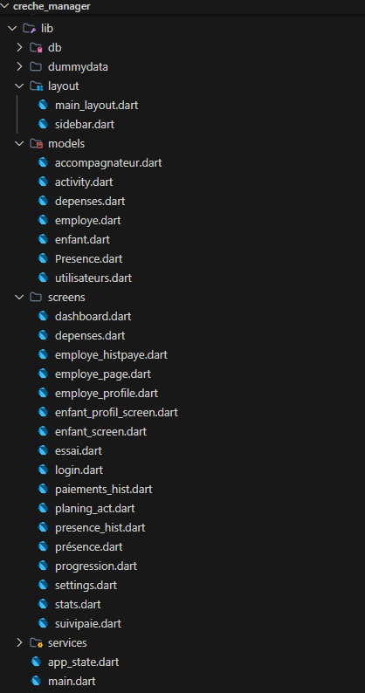
Figure 4.2: Project structure organization

Authentication Interface

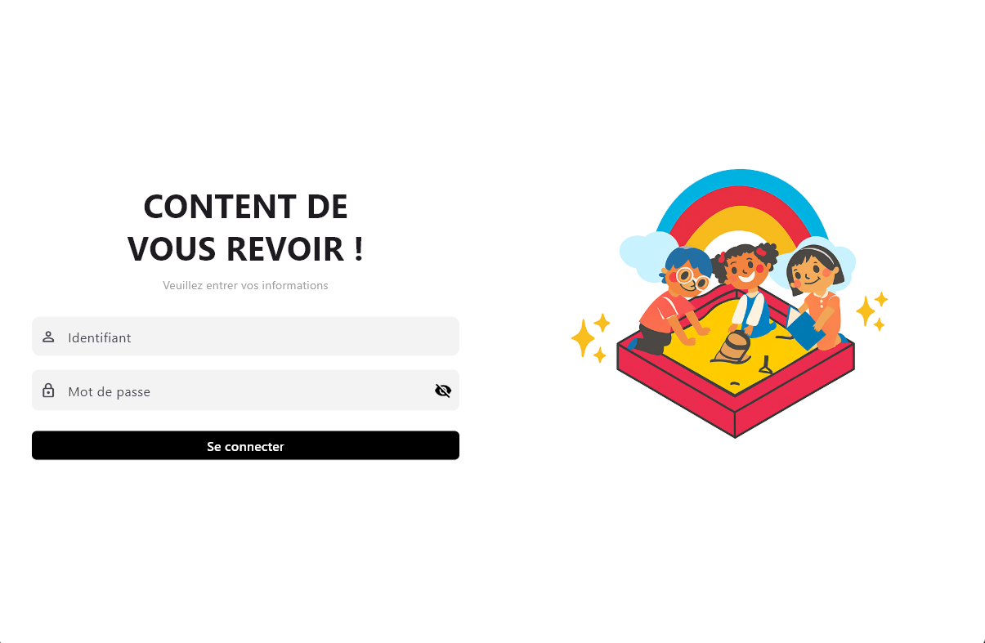
Figure 4.3: Authentication interface

- The authentication interface allows users to access the application by entering their login credentials. The system supports two types of users: Administrator and Standard user, each with different access levels.
It ensures that only authorized users can enter the system and access its functionalities securely..

Dashboard

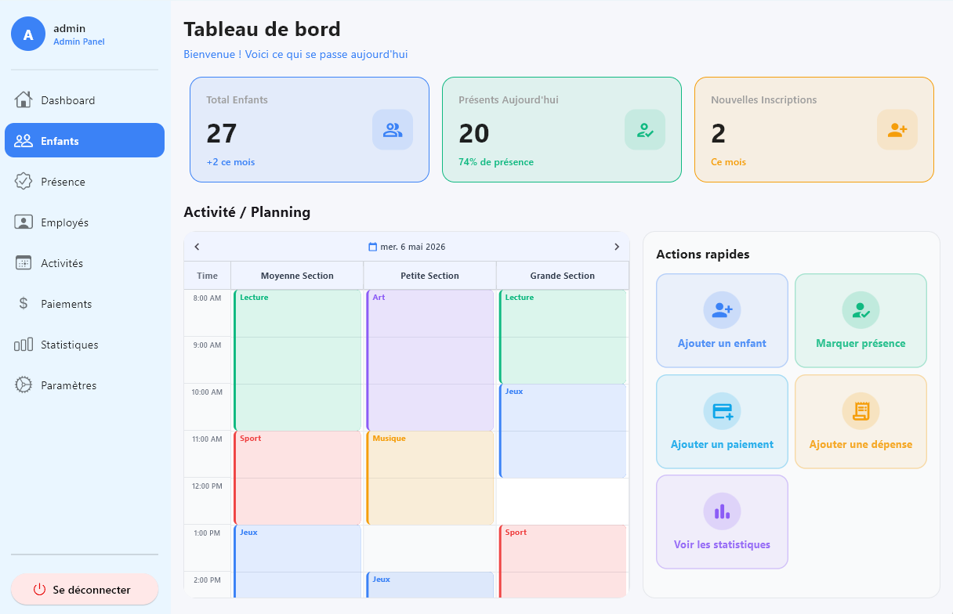
Figure 4.4: Dashboard interface

- The dashboard provides the administrator with an overview of the daycare’s activity. It displays key information such as the total number of children, monthly registrations, attendance summary, and payment status. It allows the administrator to quickly monitor the overall situation and access different sections of the application.

Children Management

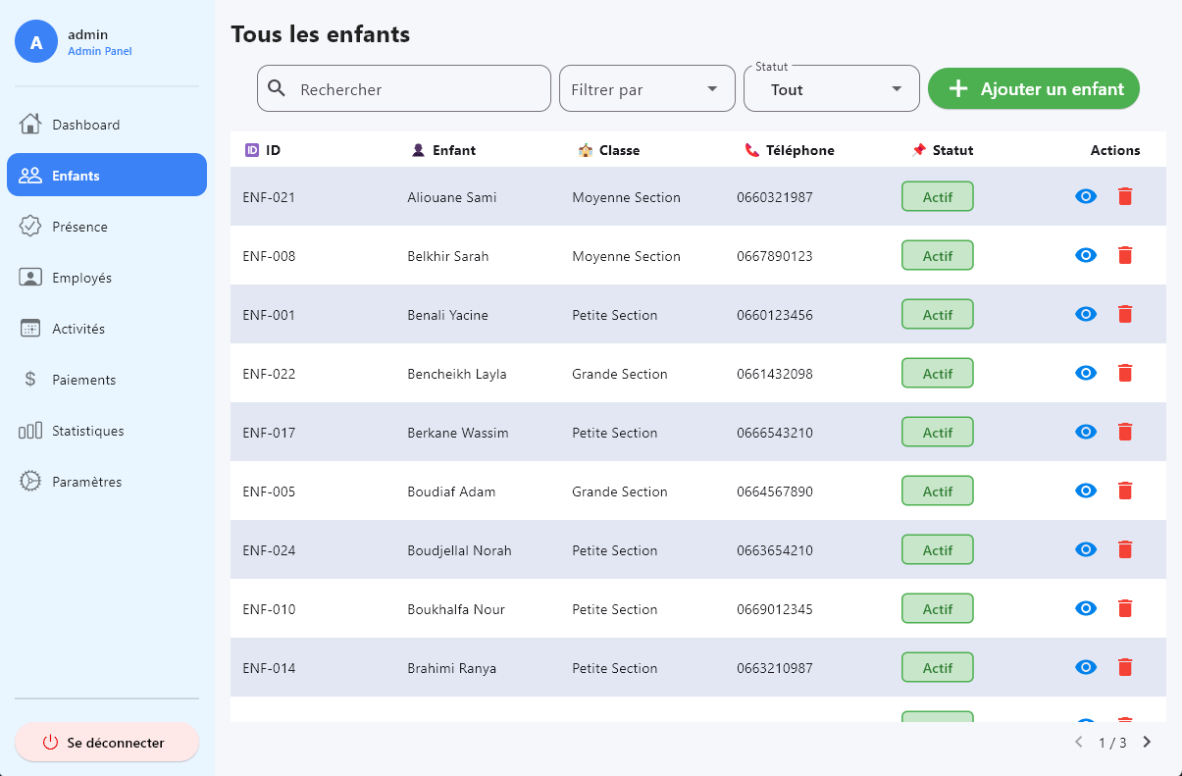
Figure 4.5: Child management interface

-This screen allows the administrator to manage all children enrolled in the daycare. The administrator can add new children, update their information, delete records, and search or filter the list. It also provides a quick view of each child’s basic information and payment status.

Child Profile

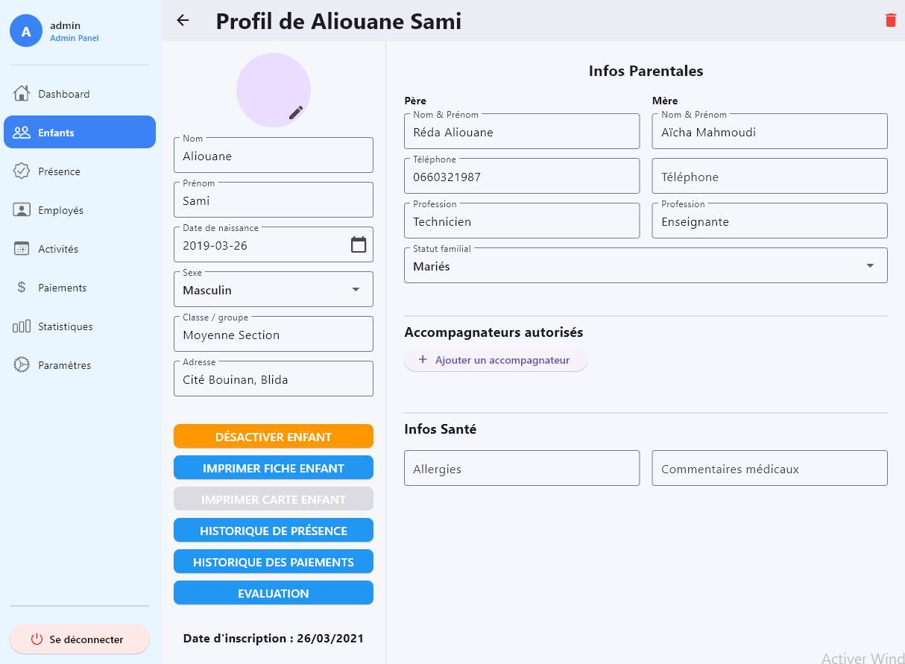
Figure 4.6: Child profile interface

-The child profile screen provides detailed information about a selected child. The administrator can view and update personal data, health information, parents’ details, and authorized pickup persons. It also allows access to attendance history and payment records, as well as printing the child’s file and ID card.

Attendance History
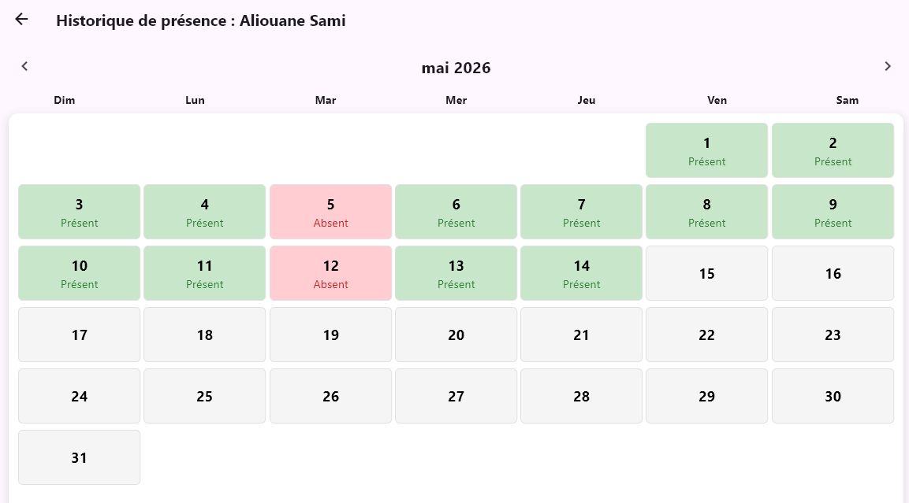
Figure 4.7: Attendance history interface

Payments History
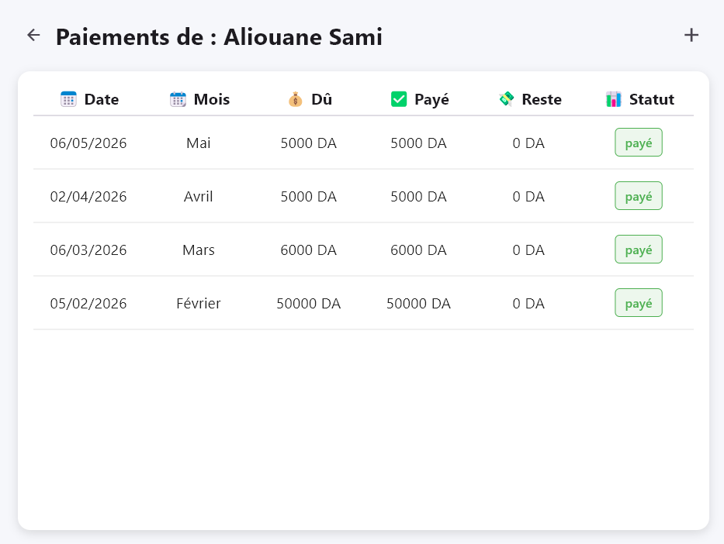
Figure 4.8: Payment history interface

Evaluations
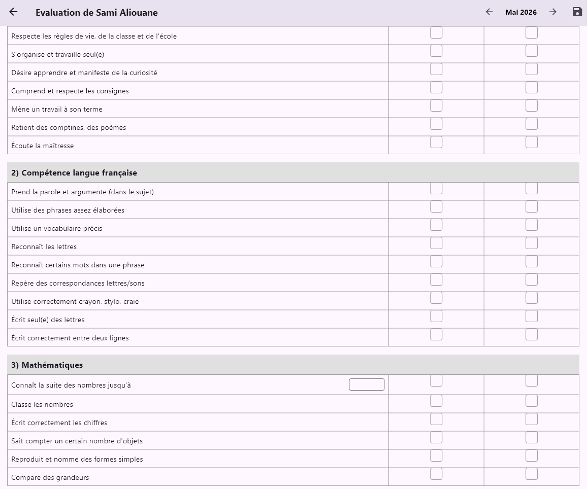
Figure 4.9: Evaluations interface

Attendance Management

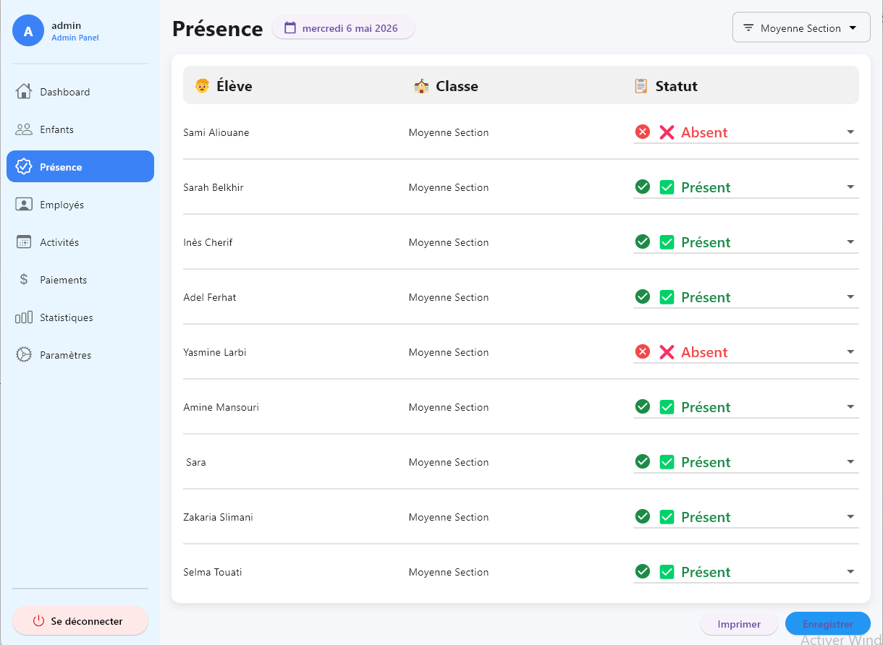
Figure 4.10: Attendance management interface

-This screen allows the administrator to track and manage children’s attendance. The administrator can mark children as present or absent and view attendance history in a calendar format. It helps in monitoring daily presence and ensuring accurate records.

Employee Management
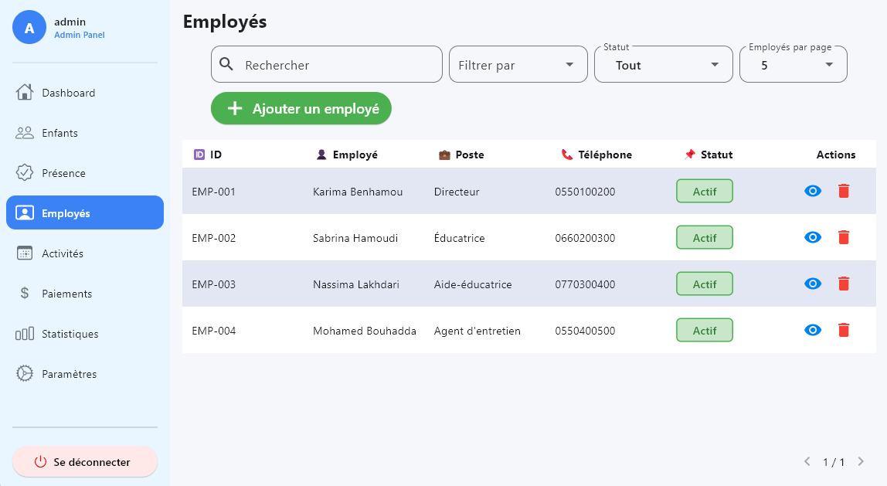
Figure 4.11: Employee management interface

- The employee management screen enables the administrator to manage staff information. The administrator can add new employees, update their details, delete records, and view their profiles. This helps in organizing the daycare staff efficiently

Activities Management
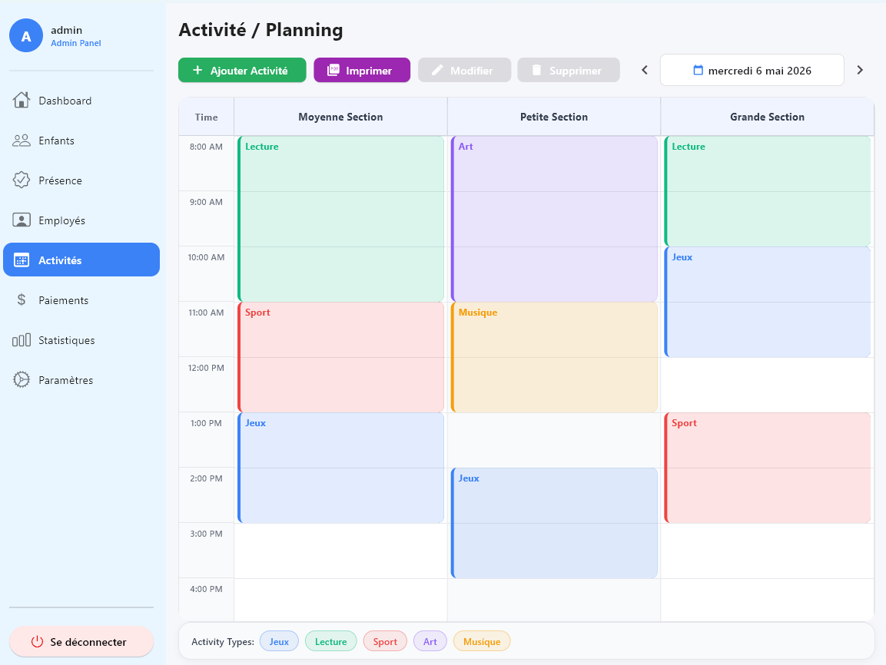
Figure 4.12: Activities management interface

-This screen allows the administrator to organize and manage children’s activities and planning. The administrator can create schedules, assign activities, and ensure proper organization of daily programs.

Expenses Management
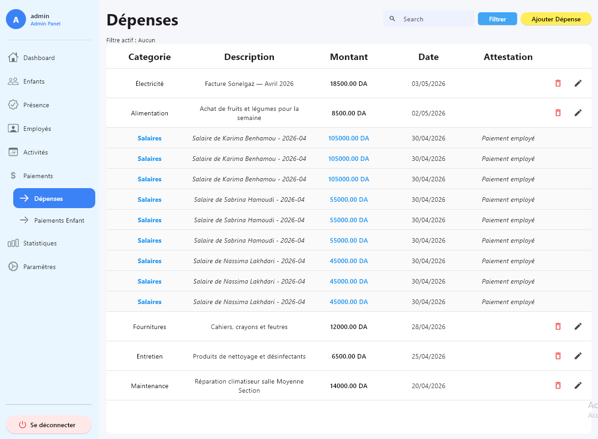
Figure 4.13: Expense management interface

- This screen allows the administrator to manage the daycare’s expenses. The administrator can add, update, and track different types of expenses, helping to maintain better financial control.

Payments Mangament
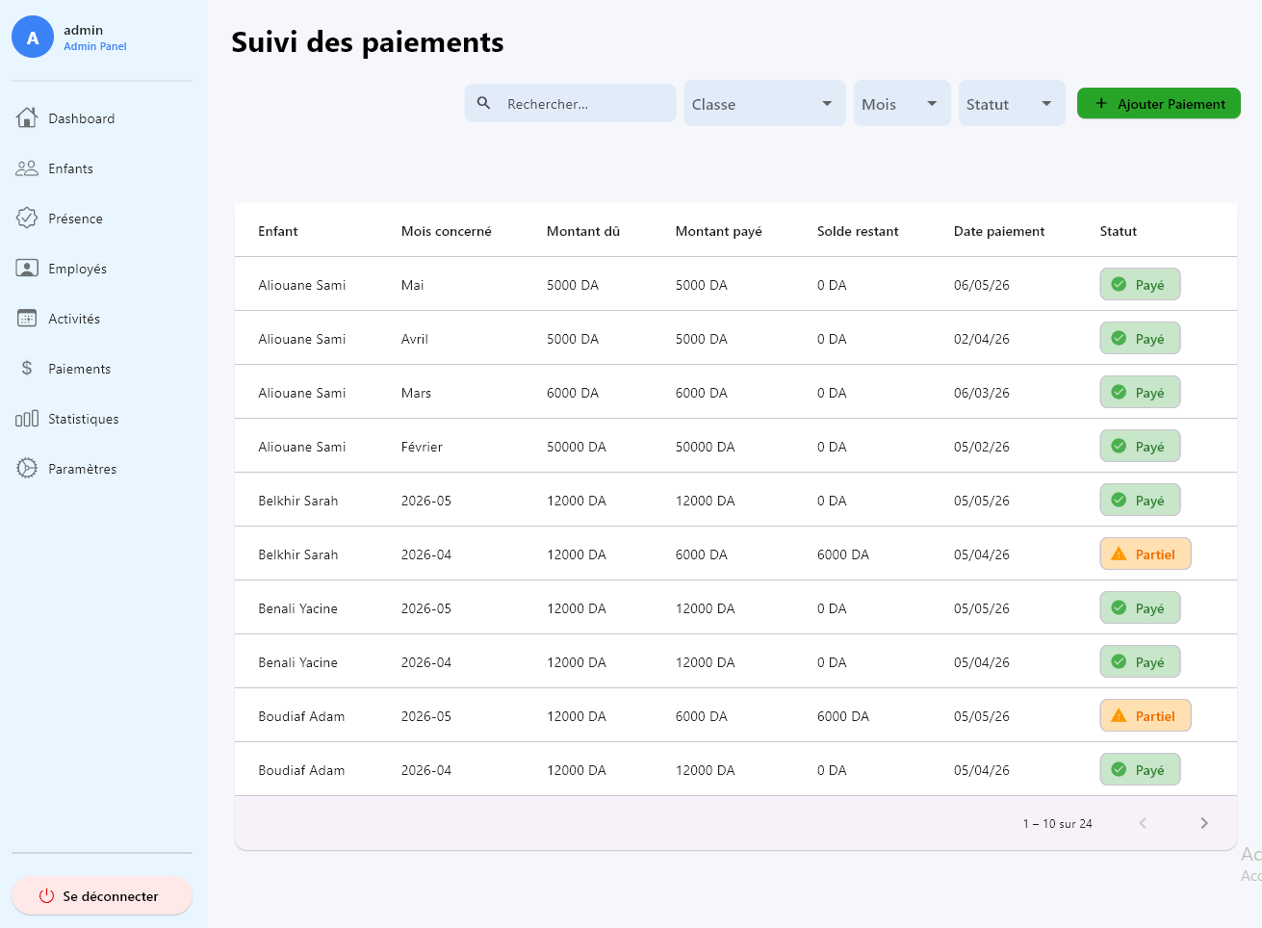
Figure 4.14: Payment management interface

- The payment management screen allows the administrator to handle all financial transactions related to children. The administrator can record payments, track payment status (paid, unpaid, partial), and view payment history. It also supports generating payment receipts.

Statistics and Charts
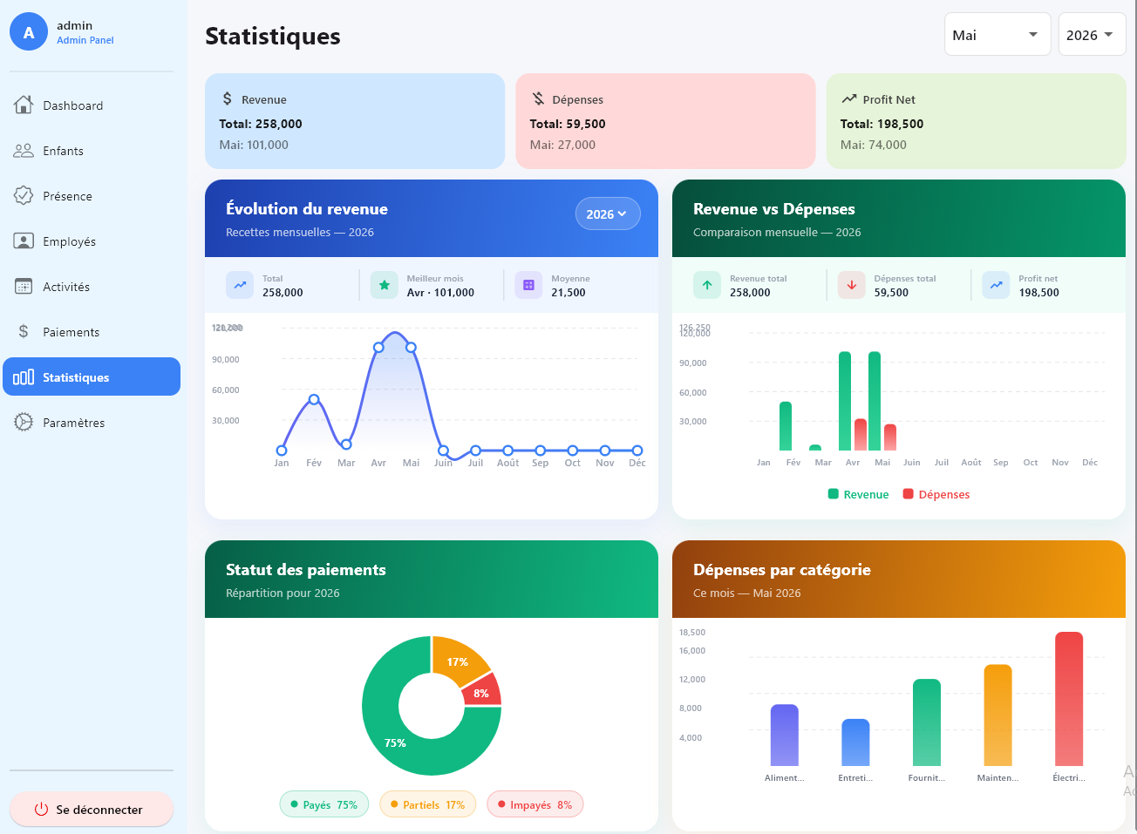
Figure 4.15: Statistics and charts interface

- The statistics screen provides visual reports about the daycare’s activity. The administrator can view charts related to children, attendance, and payments, which helps in analyzing performance and making better decisions.

Settings
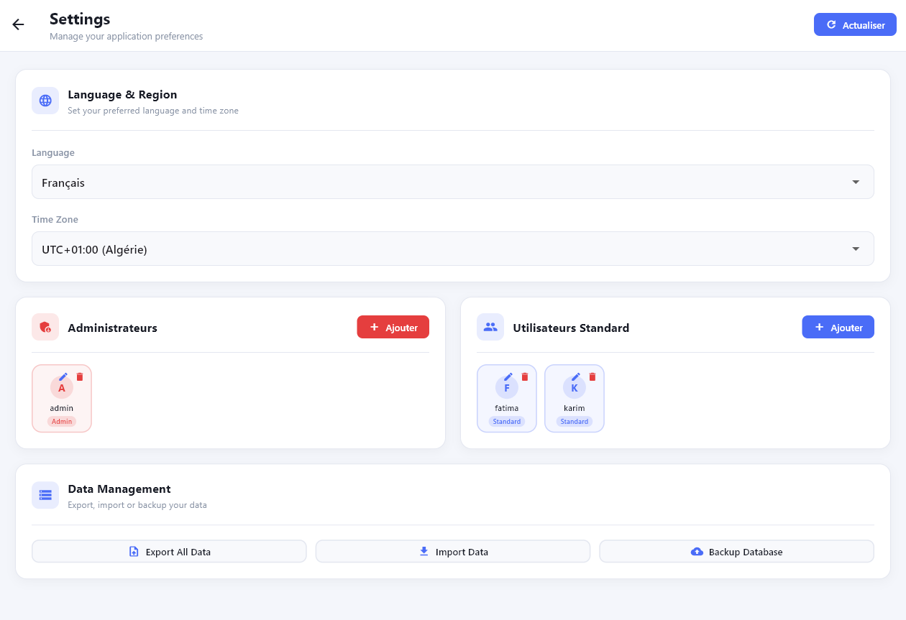
Figure 4.16: Settings interface

-The settings screen allows the administrator to configure the application. It may include options for managing user accounts, updating preferences, and controlling general system settings

Conclusion

In this chapter, we discussed the implementation phase of the daycare management system. We covered the development environment and key technologies used to develop the software, such as Flutter, Dart, SQFLite, and Visual Studio Code.

Moreover, we discussed the application architecture and project structure, which contributed to making the software highly organized and manageable. Furthermore, we described the application interfaces and key features of our application, including children management, attendance tracking, employees' management, payments, expenses, activities, statistics, and settings.

In general, this chapter demonstrated the successful implementation of the proposed solution based on previous analysis and design.

General Conclusion
From this project, we developed a daycare management app that was designed to enhance and simplify the day-to-day operations of daycare centers. The primary goal of this study is to eliminate the conventional way of managing the facility using traditional means like paperwork and other traditional techniques by introducing a computerized method.

In this project, we researched the existing system and found out the main challenges experienced when running a daycare center, namely information management, monitoring attendance, controlling the workforce, and following up on payments. Based on this information, we formulated and designed a desktop application tailored to this purpose.

Our app comprises numerous functions, such as management of children, attendance management, control over employees, scheduling activities, monitoring payments and expenses, as well as creating reports. These functions allow for better organization, decrease in manual labor, and easy access to data.

This project was also an opportunity for us to practice our programming skills through the use of Flutter, Dart, and SQFLite technologies and UML modeling.

Lastly, our application could still be enhanced in the future by incorporating additional functions such as interaction with parents, online services, notifications, and cloud backup.

References
- Google. Flutter Documentation.
https://docs.flutter.dev
- Google. Dart Programming Language Documentation.
https://dart.dev
- SQLite Organization. SQLite Documentation.
https://www.sqlite.org/docs.html
- sqflite Package Documentation.
https://pub.dev/packages/sqflite
- Object Management Group (OMG). Unified Modeling Language (UML) Documentation.
https://www.uml.org
- Sommerville, I. Software Engineering. 10th Edition, Pearson Education, 2015.
- Royce, W. W. “Managing the Development of Large Software Systems.” Proceedings of IEEE WESCON, 1970.
- Microsoft. Visual Studio Code Documentation.
https://code.visualstudio.com/docs

